Predicting Automobile Engine test results of various configurations
16/03/2018

PHD

Insofe

Team Members | Student ID
Ravi Krishna Kyram | 1542

A Study on Automotive Engine test results of various configurations using Statistics and analytics

Acknowledgements

I would like to take this opportunity to express our profound gratitude and deep regards to our Insofe professors, data scientists for mentoring and constant encouragement for gaining the knowledge on statistics & analytics..

We are deeply indebted to all of them and welcome this opportunity to benefit further from their contribution. In particular, we wish to express our special thanks to batch mates who provided their valuable suggestions during the course.

Ravi Kyram

Table of Contents

Overview……………………………………………………………………………………………..4
About the dataset………………………………………………………………………………..5
Attributes……………………………………………………………………………………………..6
Customer Demographics- NSW state……………………………………………………7
Linear Regression Model………………………………………………………………………8
Output…………………………………………………………………………………….. ………..13
Reference…………………………………………………………………………………………..13

Predicting test results of automobile engine on various configurations using statistical tools and analytical techniques

Overview

This data is simplified and anonym zed version of real automobile engine test data. A leading car manufacturer is designing an automobile engine. It is required by law and regulations, that a given engine configuration is goes through rigorous engine bench test before it is passed for production. Each bench test is an expensive, noisy and time consuming process. Instead the manufacturer would like to use some previous data on various configurations tested and determine through analytics model if their new design will pass or not. This will help them narrow down only few configurations for further testing on physical bench test. Your task is to build that model for them.

About the dataset

Primary Data Files:

Train: Training data with target variable (‘y’) which represents outcome of the bench test.
Test: Data on which your model will be evaluated on grader.
Sample submission files: Make sure your submissions matches the format/template given in this file. The target values are randomly generated only for illustration.
Additional Data Files:

This data is related to other similar but not identical test performed on the same configuration. Data is provided for two tests (Test A and Test B). Values under Test A and Test B corresponds to Engine ID in your primary data. If a particular Engine ID is present under Test A, it has passed that particular test. If that ID is not present, then it has not passed that test. Similarly, values under Test B can be interpreted. Note that neither Test A nor Test B is required or guarantees passing the final Engine test. (Target variable ‘y’). However, if an engine has passed both Test A and Test B, then it may be potential indicator of final test performance along with other parameters.
.

Understanding the business issue, identification and exploration of the data sets:
Each bench test of an automotive engine is an expensive, noisy and time consuming process. Instead the manufacturer would like to use some previous data on various configurations tested and determine through analytics model if their new design will pass or not .

We navigated through the data set and understood that test data (1053 records) and training data (3156 records) all pertaining to automotive engine. The data set consists of all categorical variables.
Attribute no. of cylinders is given as Integer type and we have to convert that variable to factor.
Y – Target variable available in Train data & is not available in test data

First we have to use all the data set to know Pass/Fail on initial configuration.

Train additional data set is an additional dataset which has test results of other configurations. We need to combine the test results with initial train data set and train the model again for the test results of other configurations as well

Attributes

The claim training dataset has got 3156 records in total with 21 independent attributes & 1 target variable. The data has details related to the automotive engine parameters

The following is the list of variables
S.No | Attributes
1 | Number of Cylinders
2 | material grade
3 | Lubrication
4 | Valve Type
5 | Bearing Vendor
6 | Fuel Type
7 | Compression ratio
8 | cam arrangement
9 | Cylinder arragement
10 | Turbocharger
11 | Varaible Valve Timing (VVT)
12 | Cylinder deactivation
13 | Direct injection
14 | main bearing type
15 | displacement
16 | piston type
17 | Max. Torque
18 | Peak Power
19 | Crankshaft Design
20 | Liner Design

Data Exploration:

- Missing values treatment (replace with KNN – imputation)
- Remove main bearing column as it shows only one factor & also remove ID column
- Converting no. of cylinders attribute to a factor
- Combine the Test A & Test B columns to the train data from additional train data(observation: After merging if engine ID is not available in new configuration data converts to NA)
- Convert all NA s in Test A & Test B columns to 0.
- Convert into factors of newly added Test A & Test B columns
- Decode the levels of Target variables to 0 & 1
- Split the Train data into train_data & valid_data into 70 % and 30 % ratio

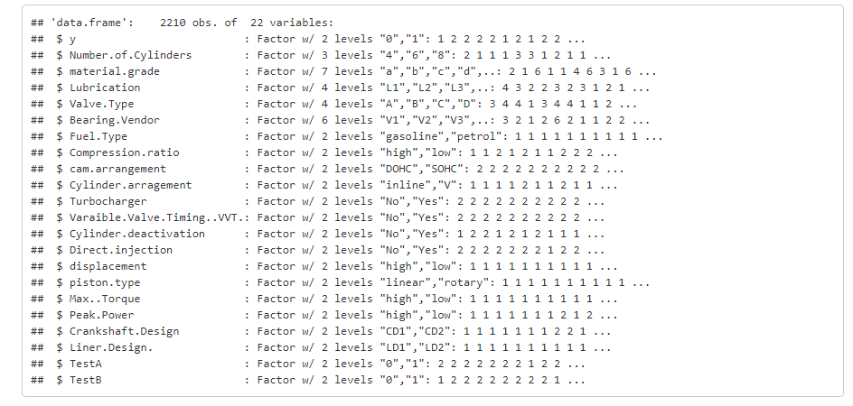

Demographics: Variables

It has least correlation between categorical variables of all levels as per the below correlation plot.
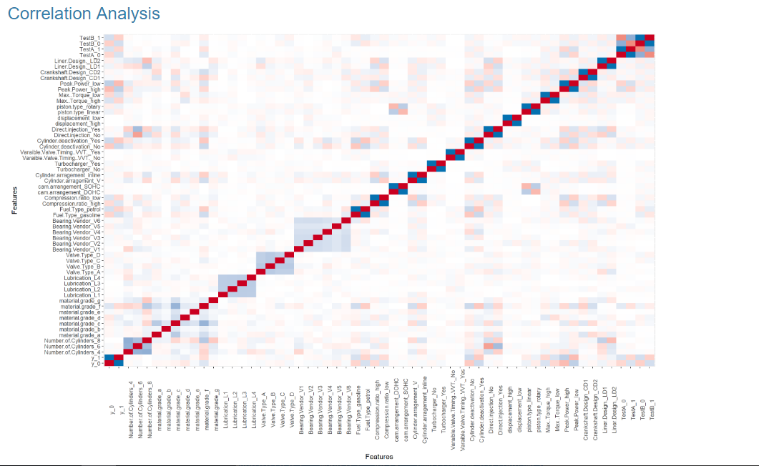

Observations from the inputs:
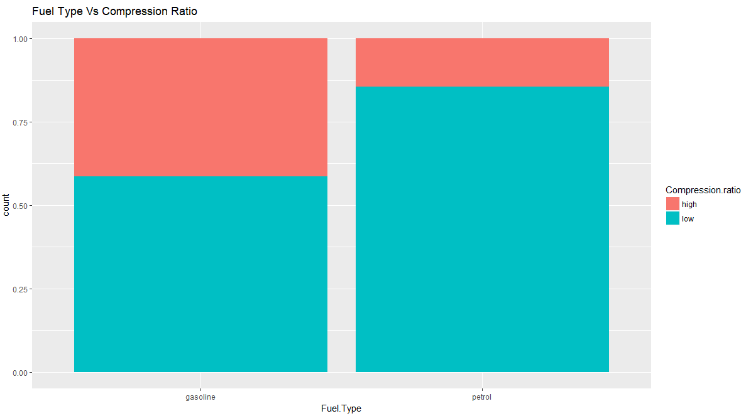
It has been observed that gasoline engine compression ratio low for about 60% engines and high for 40% engines where as for petrol engines almost 80% engines have low compression ratio .

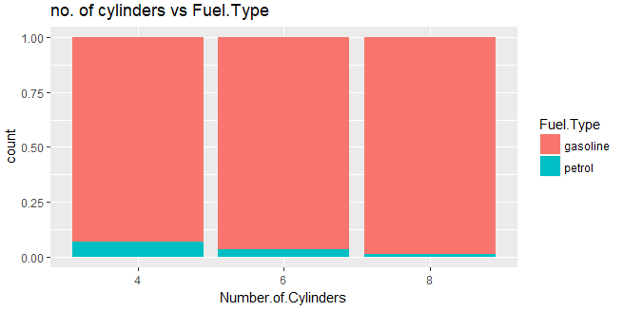
As no. of cylinders increases the petrol engines are less.

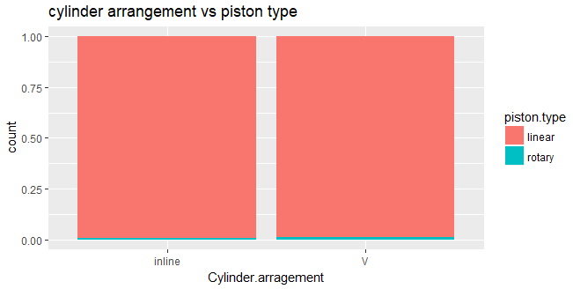
Rotary pistons are used more v cylinder compared to inline cylinders.

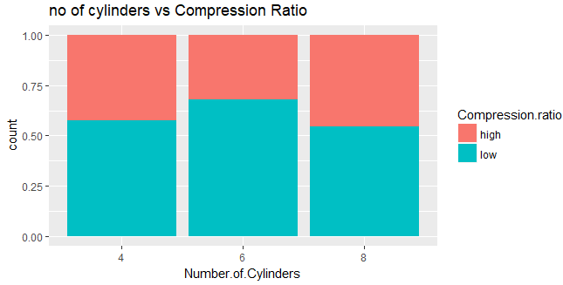
In 6 cylinders low compression ratio is used more compared to other type of cylinders

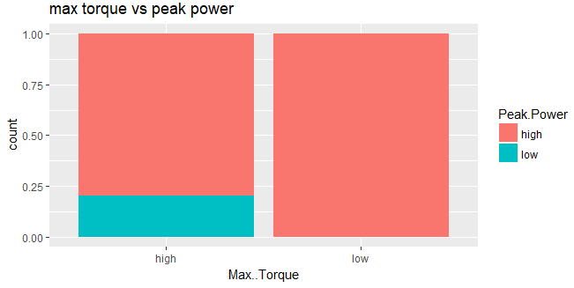
If peak power is used in engines then torque should be low

Decision Tree:

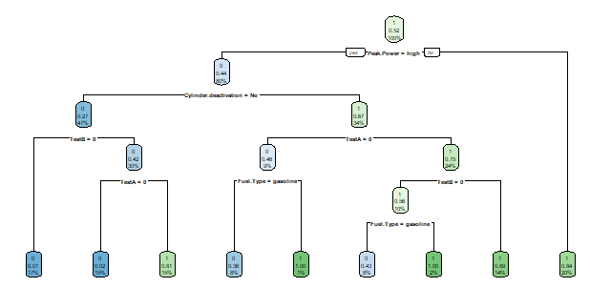

Train Data: Test Data
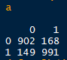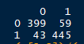

Accuracy : 86 % Accuracy : 89%

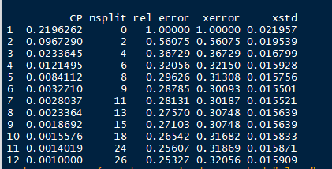

Consider cp = 0.032710 for rpart

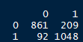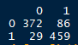

Accuracy 86% Accuracy 87%

using C5.0 (For Classification Problem)

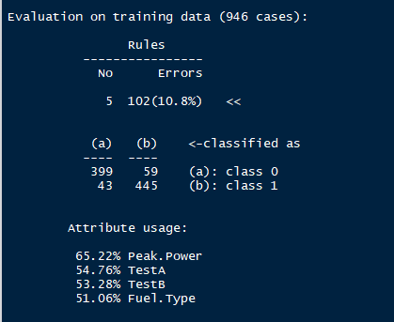

Accuracy 87% Accuracy 89%

##### Random Forest ##############

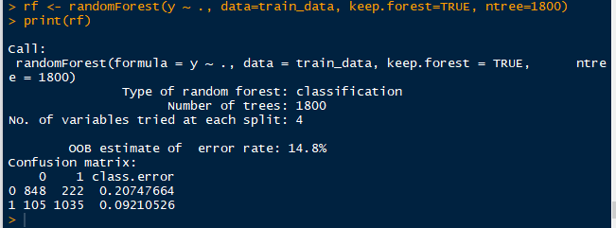

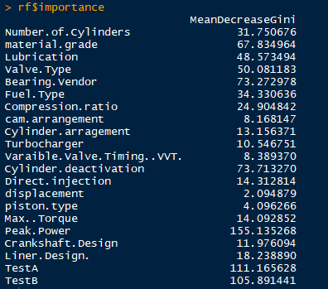

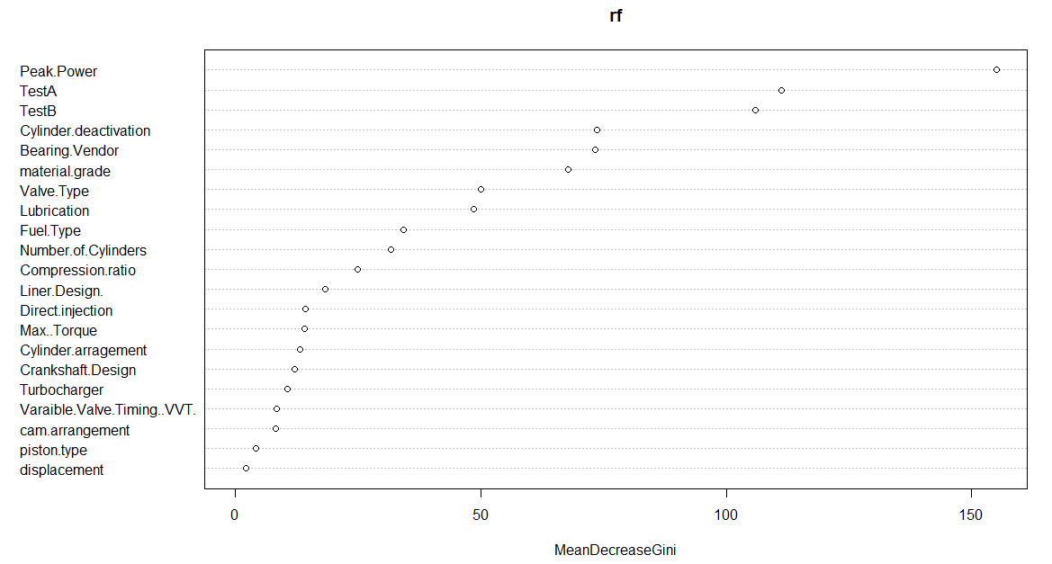

Tuning to get ntree

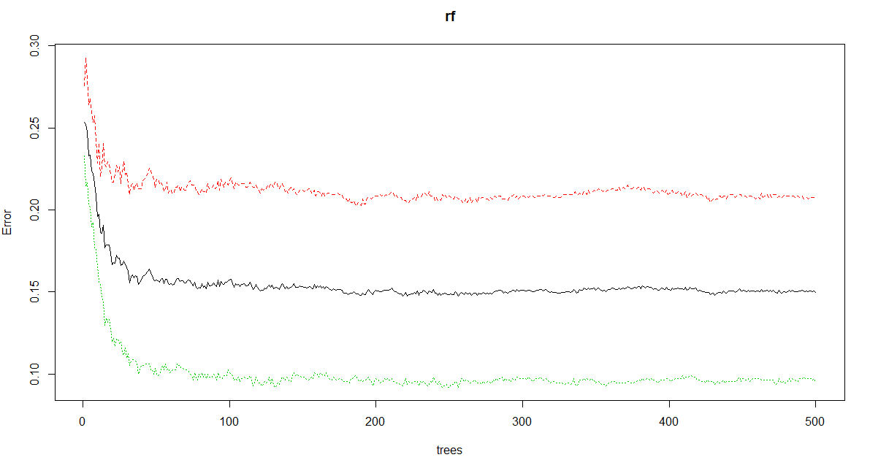
Tuning to get mget value
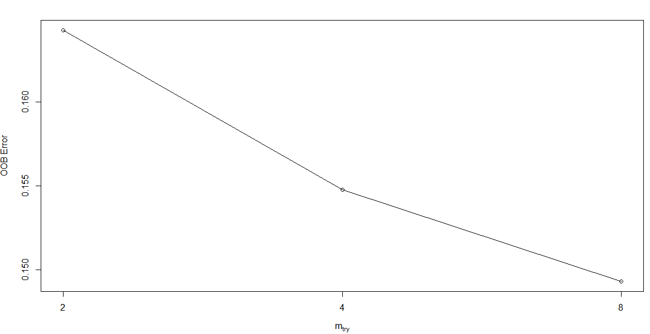
To know no of nodes

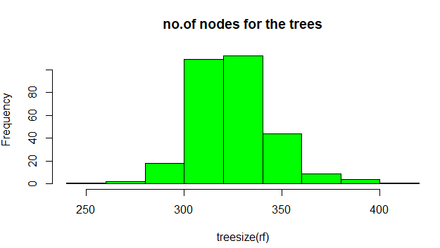

To know important variables for model accuracy

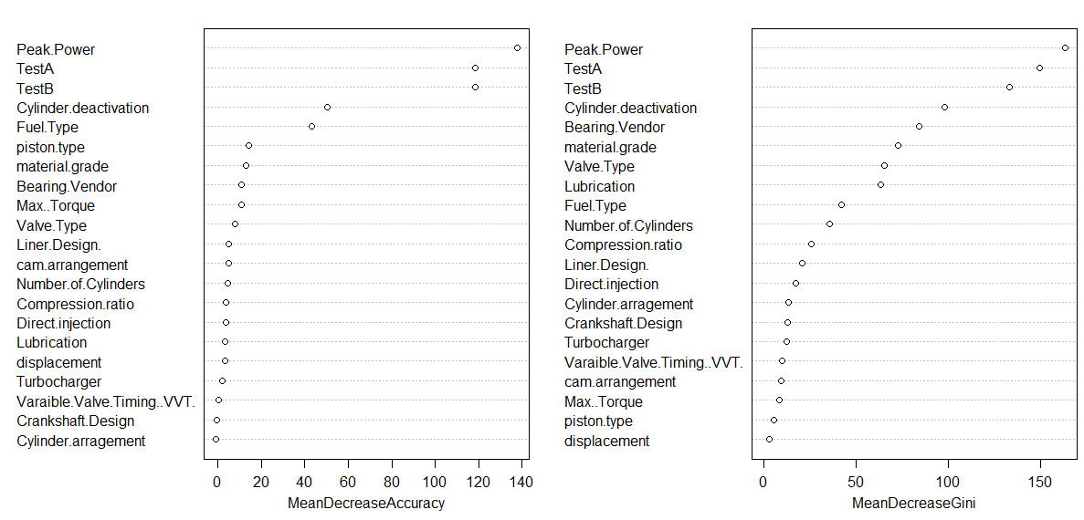

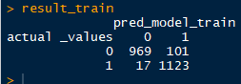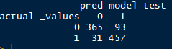

Accuracy 94 % Accuracy 86%

Naïve Bayes :

Accuracy 96% Accuracy 79%

SVM Model:

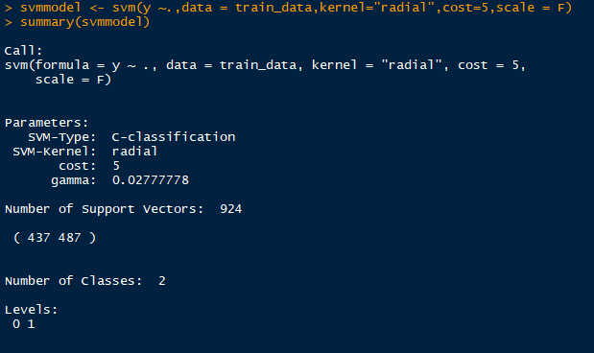

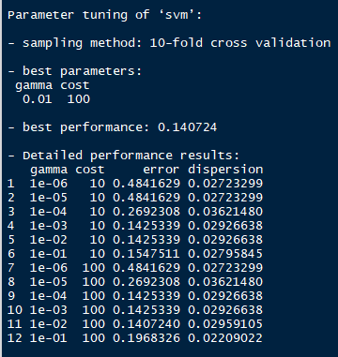

svmmodel1 <- svm(y ~.,data = train_data,kernel="radial",cost=10,gamma =0.01,scale = F)
summary(svmmodel1)

Accuracy 87 % Accuracy 89%

XGBOOST:

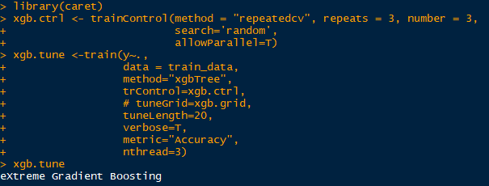

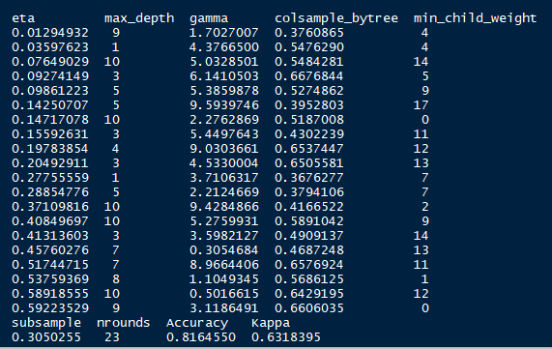

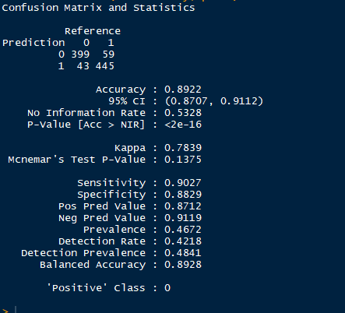
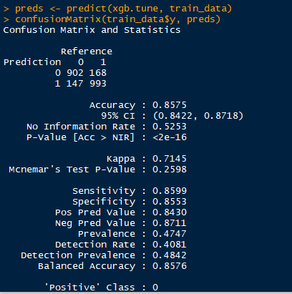

Conclusion:

Accuracy Percentage:

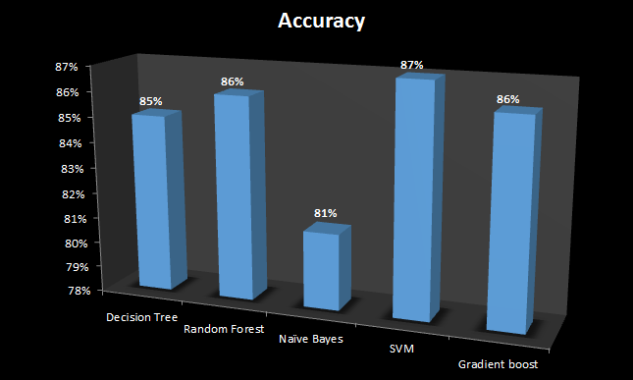

Machine Learning  Algorithm | Accuracy Percentage Score | Error Percentage
Decision tree | 85 | 15
Random forest | 86 | 14
Naïve Bayes | 81 | 19
SVM | 87 | 13
Gradient boost | 85 | 15
Conclusion:

SVM Model is giving the better accuracy (87%) to identify the test failures of Automobile Engines of various configurations.

